Panmure District School News

No.03 - Term.2, Week 03 –Monday 15 May 2017

Greetings, Kia ora, Talofa lava, Kia orana, Malo e lelei, Fakalofa Lahi Atu, Namaste, An Young Haseyo, Konichiwha, Bula Vinaka, Sawadee, Dobra Dan, Ni Hao, As-salamu alaykum, Hola

Trip to Buddhist Temple
An interesting trip for our students to the Buddhist temple. They were able to interact and understand the concept of sharing and working together as a group. The children were very happy from this trip.

Hockey Sessions
Hockey training sessions is run every Friday at school by New Zealand Hockey till 09 June. An exciting opportunity for our students to participate and learn new skills.


Breakfast in Schools
Breakfast in Schools Programme is run from 8.00am to 8.20am in the school hall. Children who are interested please come along and join Mrs. O’Neil in the hall.


Panmure District School Bake-off Programme
A reminder to all parents that the Baking Programme is run every Wednesday morning this Term. If you are interested please assemble in the school hall at 9:00am. We look forward to seeing as many parents as possible.



Merit Awards
Room 3 –
Dipasha Prasad for her great effort in writing.
Mormon Schwenke for his great effort in writing.

Room 5 -
Krishna Patel for gathering additional information on topics that interests her.
Jasper Sanidad for developing interest in reading a variety of books.

Room 6 -
Josiah Vea for always trying his best.
Hazel Godoy for settling into class routines and working diligently on all tasks.

Room 9 -
Krishan Patel for using counting on strategies to solve addition stories.
Ritty Ty-Em for settling into class routines.

Room 10 –
Taral Turua for confidently speaking to groups and class.
Emmanuel Suamili for expressing his viewpoints on a topic.

Environmental Awards – Room 5
For setting up the Hall in preparation for Assembly each week.

Duffy Awards
Miracle Vaovasa for inspiring others to try harder.

Mariann Ares for being a kind and caring group member.

Toapasi Toki for using decoding strategies to read unknown words.

Evnik Ram for writing interesting stories and including facts and opinions.

David Lotufaafetai for using strategies to work out unknown words.

Abigail Vea for good reading habits an including homework activities.

Ztahry Taliai for showing pleasure and enthusiasm in discussing reading.

Children sharing their trip experience –

Visit to the Buddha Temple
On Wednesday the 10th of May, Panmure District School visited the Fo Guang Shan Temple, 16 Stancombe Road Flat bush in Manukau. It was a radiant and enlighten, glamourous day with no clouds to be seen. There was a soft shade of blue and a slight gentle breeze in the sky! The sounds of little sparkling bells and laughter filled the air with excitement.

The venue that we attended was outstanding and exquisite! There were monks and members of the temple were waiting patiently to greet us with smiles stretched from ear to ear! As soon as we hopped out the buses we all scrambled together in front of the doors and were split into groups 1, 2, 3 and 4! The monks than greeted us in their language - Gi Sheng, which means ‘hello’. We were shown around the inside of the temple.

The most important things, they explained to us were the 4 G ‘ and the ‘3 G’, which teaches us to Give Others Hope, Give others Joy, Give Others Convenience and Give Others Confidence. The 3 ‘G’s’ are: Do Good Deeds, Say Good Words and Think Good Thoughts.
We also wrote our own wishes on a piece of paper and stuck on the wall. We poured water on the golden child Buddha saying the ‘3G’s’. Another good thing is they gave us some brownies and water and a wind chime each with the 3G’s and the 4G’s.

The whole experience was unforgettable and really good. The place is so serene and quiet. Very good for meditating. I would love to go back there again.

By Bronte Tonga, Year 8
Room 5

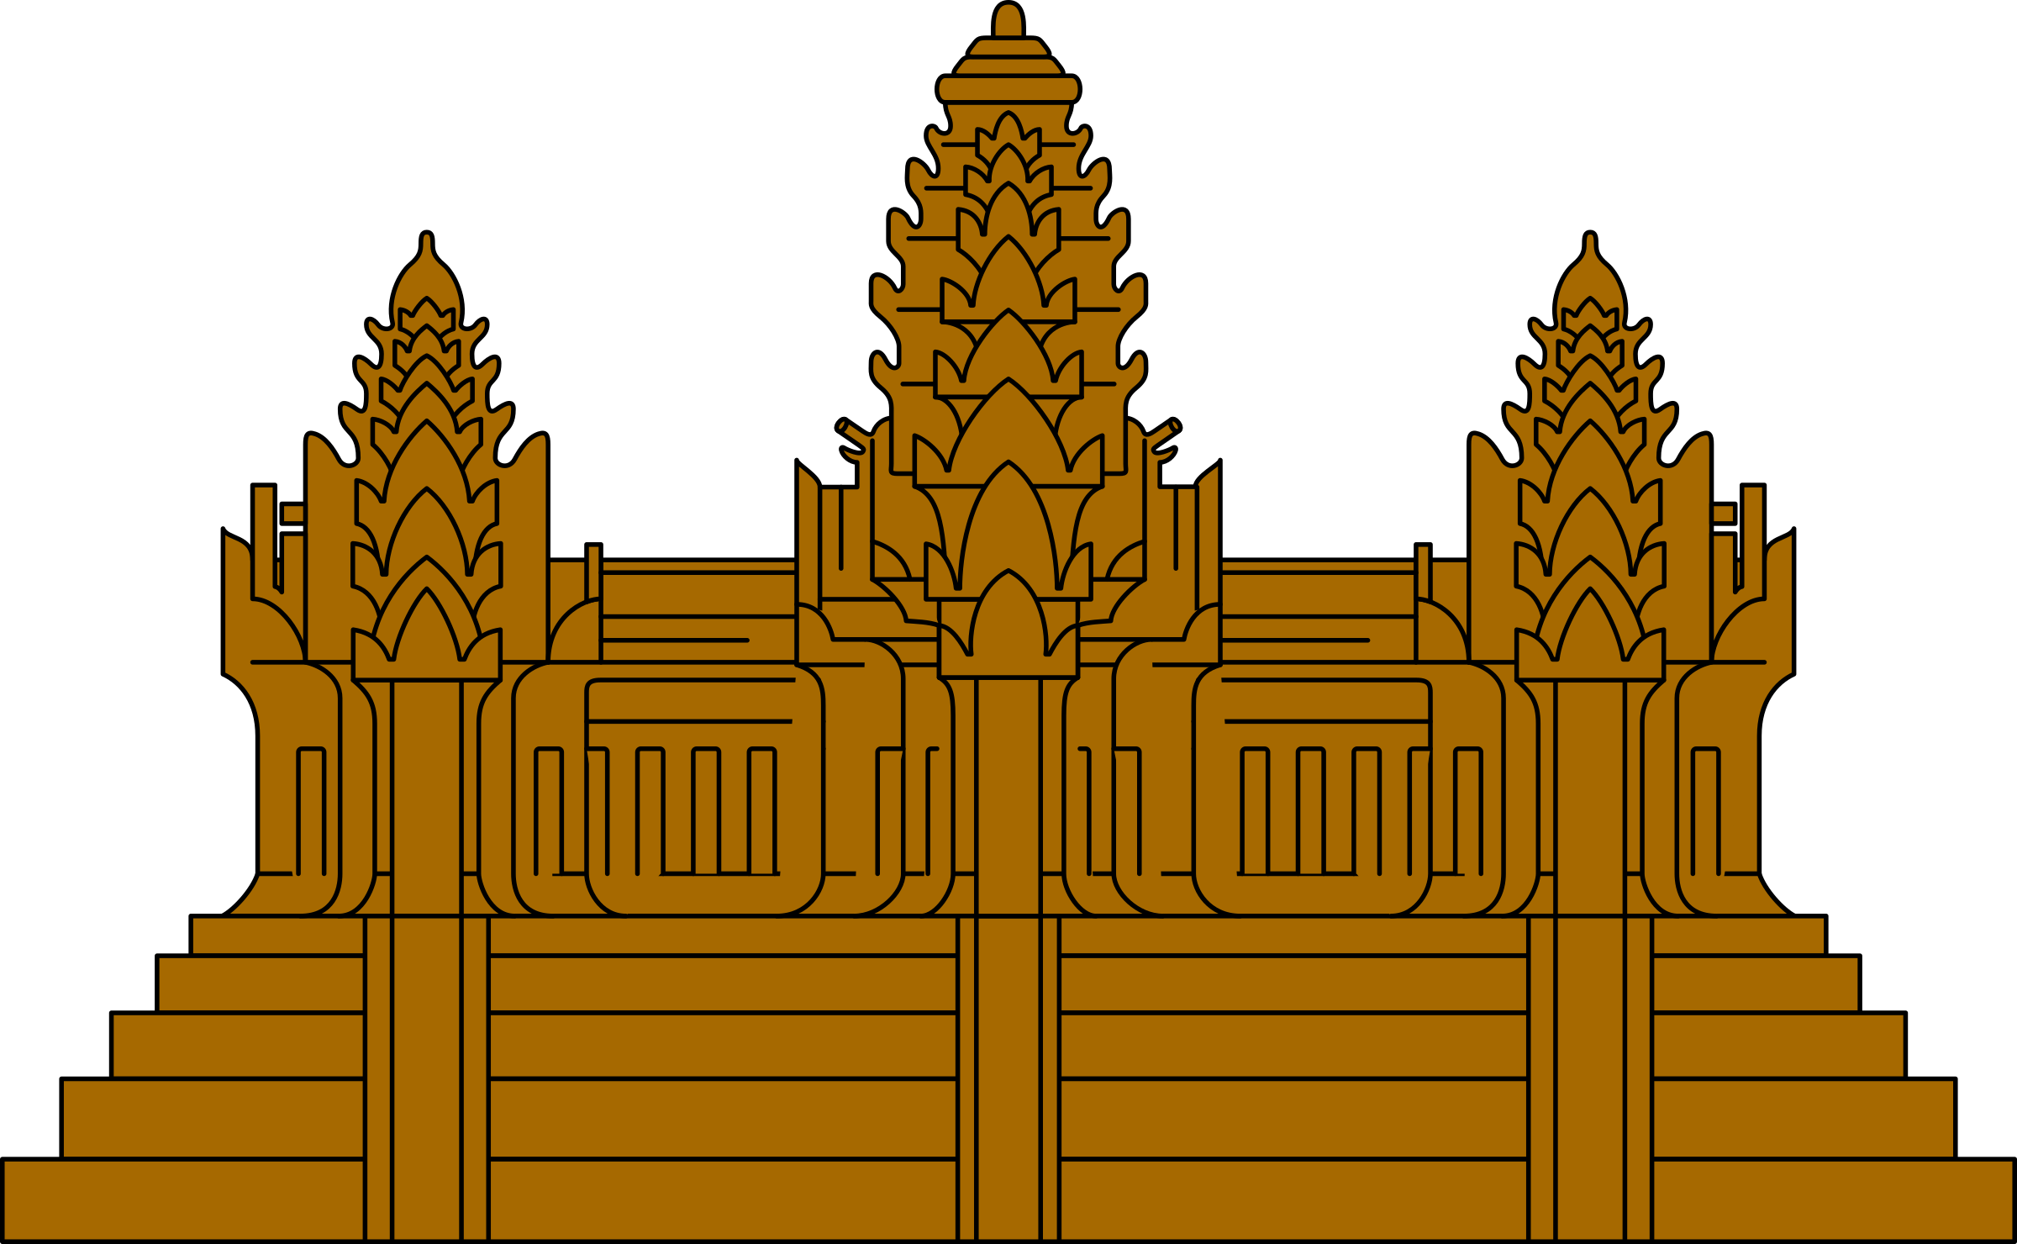

The Buddhist Temple Visit
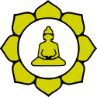

On Wednesday 10th May the whole school went on a trip to the Buddha Temple in Flat Bush, Manukau. We all lined up in the hall waiting for the bus to arrive very patiently. Then we were off to the Temple arriving there around quarter past ten.

When we arrived there, people were standing near the Temple with the numbers – 1, 2, 3 & 4 so we had to get into groups. Then they were welcoming us and telling us about 3G and 4G.

Then we made our way to the Temple near this little house and we got to wash Buddha’s body and also learn about 3G. The meaning of 3G is to say good words, think good thought and do good deeds. The meaning of 4G was to give others confidence, give others joy, give others hope and give others confidence.

After that session we went to another room to write a wish and we don’t just write a wish, we have try to make it come true. Then we went outside to make a lotus flower and lay on the grass. Later on we had our snacks and observed the police do a little drama for us.
Before we left the Temple, we were given a small bell to remind us about 3G and 4G.

It was a really an awesome experience to learn about an amazing culture.

By Patilda Tuafafo, Year 8
Room 3

